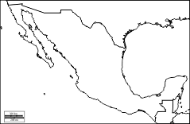

Place the following items on the map of Mexico and its neighbors. Then color the map appropriately.
Sierra Madre Mountains Gulf of Mexico
Rio Grande Gulf of California
Mexico City Guatemala
Baja Peninsula Belize
Yucatan Peninsula United States
Pacific Ocean Caribbean Sea

